**PROJECT DOCUMENTATION**



**GROUP PROJECT**

**GROUP MEMBERS:**

* **Awais Tahir - 232387 – BSCS-Eve-B**
* **Abeera Zainab – 232997 – BSCS-Eve-B**

**PROJECT: CREATING A WEBSITE**

**TITLE:**

**DENTAL HUB WEBSITE**

# **Introduction:**

This project is about making a dental care website that involves careful planning to ensure that the site meets the needs of its users and complies with relevant regulations. Dentalcare website is a digital platform specifically designed to provide information, services, and resources related to health and medical topics related to teeth hygiene. Whether you're looking for tips on oral hygiene, seeking information about common dental procedures, or exploring the latest advancements in dental technology, you've come to the

Purpose Of Dental Website:

A dental website serves several important purposes, catering to the diverse needs of patients, practitioners, and the broader dental community.

1. Information and Education:

Dental websites provide valuable information and educational resources on oral hygiene, common dental procedures, and the latest advancements in dental technology. These resources empower patients to make informed decisions about their oral health and treatment options.

1. Access to Dental Care:

Dental websites often include features that facilitate access to dental care, such as appointment scheduling, information on dental services offered, and directories of dental professionals and clinics.

1. Research and Guidelines:

Websites may also serve as repositories for dental research, treatment guidelines, and best practices, providing valuable resources for both patients and practitioners.

1. Promotion of Oral Health:

Dental websites often promote oral health awareness and preventive care, offering tips, guidelines, and resources to encourage good oral hygiene practices and overall wellness.

## **Audiences of a Dental Website**

A dental website targets to a diverse range of audiences, each with specific needs and according to their interests. Here are the key audiences of a dental website:

1. Patients and Prospective Patients:

The primary audience of a dental website includes individuals seeking dental care, information about oral health, and details about specific dental procedures. These individuals may be looking for a new dentist, seeking information about a specific treatment, or researching oral hygiene practices.

1. Existing Patients:

Dental websites also serve as a valuable resource for existing patients, providing them with access to important information about their ongoing dental care, appointment scheduling, and post-treatment instructions.

1. Dental Professionals:

Dentists, dental hygienists, dental assistants, and other dental professionals are also an important audience for dental websites. They may seek professional development resources, industry updates, and best practices in their dental care website.

1. Caregivers and Parents:

Caregivers and parents, especially those with young children, are a significant audience for dental websites. They often seek information about pediatric dental care, oral hygiene for children, and guidance on maintaining their family's oral health by connecting online with their doctors .

1. Referring Healthcare Providers:

Dental websites may also cater to healthcare providers who refer patients for dental care, providing them with information about the services offered, referral processes, and collaborative care opportunities.

Website sketch (On Figma):

These images outlines a basic website sketch created using Figma. This sketch serves as a foundational model for our website development, providing a visual representation of the website's layout and structure. Please note that this sketch is a work in progress and is subject to modifications as we gatheruser feedback and refine our design approach.

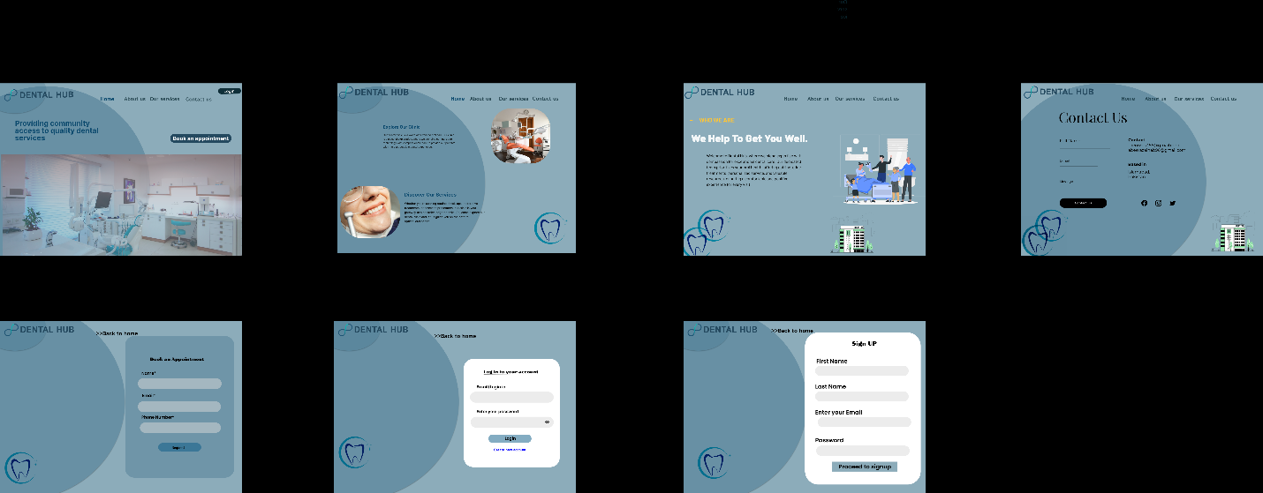

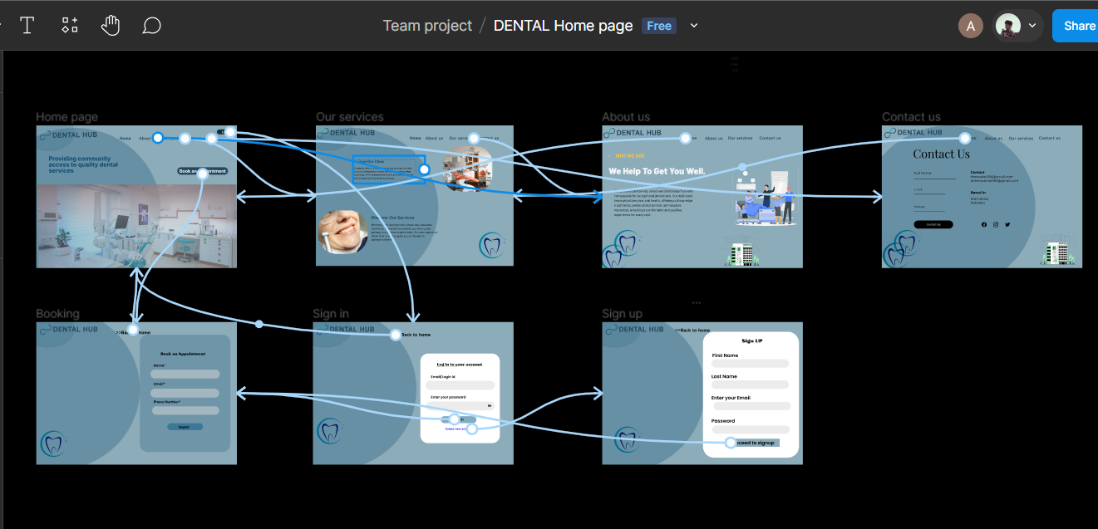

* These are prototypes added to different layout

Link to Figma Website:

[**https://www.figma.com/file/U1K7Kd4rkymPkQShOrfveH/DENTAL-Home-page?type=design&node-id=0%3A1&mode=design&t=kJbvn73LHQis5LyH-1**](https://www.figma.com/file/U1K7Kd4rkymPkQShOrfveH/DENTAL-Home-page?type=design&node-id=0%3A1&mode=design&t=kJbvn73LHQis5LyH-1)